OpenOffice Linguistic Tools add-on (OOLT)

1.Getting Started 2
1.1.Overview 2
1.2.Requirements 3
1.3.Installation 4
1.4.File formats 5
2.Add-on instructions 6
2.1.Phonology 6
2.1.1.Exporting Data Files 6
2.1.2.Getting Examples into OpenOffice 7
2.2.Grammar 9
2.2.1.Exporting Data Files 9
2.2.2.Grammar Settings 10
2.2.3.Updating Grammar Examples 12
2.3.Grammatical Abbreviations 14
2.4.Data Conversion 16
2.5.Word List 18
2.6.Spelling Tools 21
2.6.1.Compare Spelling 21
2.6.2.Change Files 22
2.6.3.List of Good Spellings 24
2.7.Script Practice 26
2.8.Advanced settings 28
3.Formatting write-ups 29
3.1.Navigator 29
3.2.Cover page 29
3.3.Page numbering 30
3.4.Table of contents 30
3.5.Outline numbering 31
3.6.LSA bibliographies 31
3.7.Other tips 32
4.Technical notes 33
5.Contact 33

Getting Started

Overview
The Linguistic Tools add-on provides a menu of tools for linguistic write-ups and other documents written in lesser-known languages.
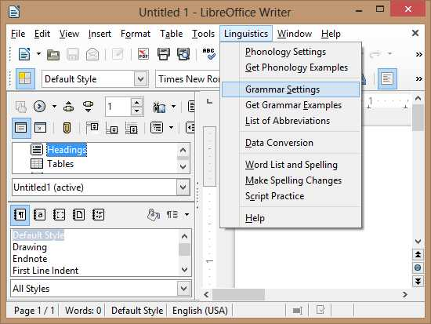
Feature | Description
Phonology Settings / Get Phonology Examples  Grammar Settings / Insert Grammar Examples | Load lexical and interlinear data from FieldWorks or Toolbox, then insert examples.
List of Abbreviations | Manage the list of grammatical abbreviations used in a writeup.
Data Conversion / Bulk Conversion | Make encoding changes using SIL Converters based on style or font.
Word List and Spelling / Make Spelling Changes | Make a word list from data files and documents, and use the list to check spelling.
Script Practice | Practice recognizing and typing different scripts.
In this help document there are also tips for setting up OpenOffice documents. Especially recommended are the tools for maintaining LSA bibliographies and citations.

Requirements
LibreOffice (LO) or Apache OpenOffice (AOO) is required. The add-on supports both brands equally, and in this document, the name OpenOffice refers generically to both. There is no python support in AOO 4.0 so please upgrade to AOO 4.1 or higher.
OOLT is tested on Windows and Linux. It should work on a Mac as well. For Data Conversion on Windows, download and install the SIL Converters application. On Linux, install FieldWorks which includes the required SIL Converters libraries.
In addition to English, this add-on can be used in Spanish or French. It should change automatically when you use OpenOffice in one of those languages (Tools → Options → Language Settings, Languages).
The latest release of the add-on can be downloaded from http://projects.palaso.org/projects/ooolt.

Installation
The add-on is installed from a file called LinguisticTools.oxt. When you double-click on this file, the OpenOffice Extension Manager will open and install it. After it finishes, open a Writer document. If the installation was successful, you will see a new menu to the right of the Tools menu called "Linguistics" as shown in Overview above.
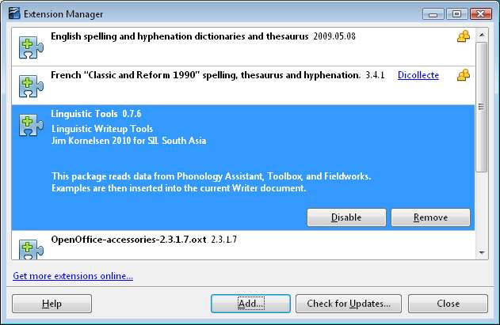
If the extension is not able to install correctly, close all open windows of OpenOffice including the quick starter and then try again.
When installing OpenOffice in Windows, the Python-UNO bridge must be selected. This is under Optional components and is selected by default. In Fedora, the Python bridge is not included by default. You must add either the libreoffice-pyuno or python-openoffice package.
If there is an older version of the add-on installed, the Extension Manager will first remove the old version. You may see an error when removing that says "Addons.xcu does not exist." Just ignore this error and press OK. To prevent this error, you can delete the user profile (check Tools → Options → Paths for the location), which will remove any existing add-ons and settings.
Sometimes removing an older version may give other error messages such as failing to close a bridge. If there are error messages like this, close all open windows of OpenOffice. Then try removing the older version again. You may also need to reboot in order for this problem to go away. Some people have reported that re-downloading the extension was needed, especially in areas where there is a poor internet connection.

File formats
To work on the document, please save the file in Writer's preferred format, which is .odt (Open Document Text). Otherwise settings for the Linguistic Tools will be lost, and other document formatting may be lost as well.
MS Word 2007 SP2 and higher should be able to read .odt files. It is also possible to save a copy in .doc or .docx format for someone else to read. However with these approaches there are usually some formatting problems. The most reliable method of saving a writeup for someone else to read is to export as PDF (File → Export as PDF).
If possible it is best to start with an OpenOffice document rather than importing from MS Word. Importing may still be your best option, but if so, expect some extra problems that need to be fixed.

Add-on instructions

Phonology

Exporting Data Files
We will start by describing how to get examples from Flex. Phonology examples come from entries in the Lexicon.
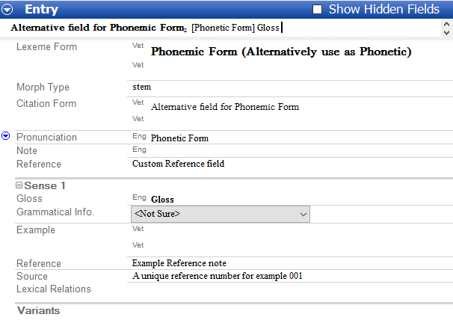
Enter the reference number in a Source note (check "Show Hidden Fields" if Source is not visible). If there are not reference numbers for the data yet, add a unique number for each entry, for example ABC001, ABC002 and so on. Use the lexical entry field for the phonemic form, and pronunciation for phonetic. Alternatively it is possible to use citation form for phonemic and lexical entry for phonetic.
When finished, export as LIFT format (File → Export). Save the files someplace where you can find them again, for example in Documents. The first time, you will probably want to make a new folder to save in, because several files will be created.
To use Toolbox, the following fields are required: \pht (Phonetic), \phm (Phonemic), \ge (Gloss English), \ref (Reference Number). Export as XML. To do this, go to File → Export, and add an XML process if it is not there yet. Then press OK to export.
To get examples from Phonology Assistant, in Data Corpus view, make sure that the "Reference" column is not empty. Also Phonetic, Phonemic, and Gloss columns should be used. If you want to use the experimental transcription feature, it will be used as the Phonetic field. When the data is ready, in the File menu, choose Export → To Phonology Assistant XML. This will create a file ending in .paxml.

Getting Examples into OpenOffice
After a data file is exported, start OpenOffice. In the Linguistics menu, choose Phonology Settings. Click on the Browse button to open the file selection dialog. Browse to the data file that you exported (for example the file ending in .paxml from Phonology Assistant) and press Open. If the data is directly from Flex, then specify the writing system and which field is phonemic. Words will be shown between slashes, brackets and quotes unless the box is unchecked. Also you can choose whether the phonetic or phonemic representation comes first.
Click OK to close Phonology Settings. Next, you can type # followed by the reference number that refers to the data, for example #0016 or #COCO.01. Then go to Linguistics → Get Phonology Examples. Check the box "Search from beginning of document" and click Find Next Reference. Now click Replace with Example. It should load the example into the document. If you have typed several reference numbers, then again press Replace with Example.
Another method is to type in a ref number in the dialog window and press the "Insert This Example" button. Many people find this method easier.
After inserting an example, you can insert a cross-reference to the example that will update automatically. Go to Insert → Cross-Reference and select type as AutoNr. Select the number in the list that was just inserted. Specify to insert reference to Reference. Then click the Insert button once, and click Close.
To change font size or color, use the Styles and Formatting pane. If you do not see the Styles and Formatting pane, go to Format → Styles and Formatting. In the pane, change the box at the bottom to view Custom Styles. Select the Character Styles icon at the top of the pane (the second icon from the left). Right-click on the style, for example Phonemic, and select Modify.
To change tabs, you should modify the Lex Example style. If you instead change tabs directly on the paragraph, then it will only change one example at a time. To modify the style, at the top of the Styles and Formatting pane, select the Paragraph Styles icon (the first icon). Right-click the Lex Example style and go to the tab named "Tabs." In the box labeled "Position," you will see the current positions of the tabs. To move one of them, create a new tab by entering the new position and then pressing "New." Then select one of the old tabs and press the button to delete it.
To update examples, go to Linguistics → Get Phonology Examples and specify to Update existing examples. Press Find Next, which will find the reference number of an example that you have put into your document earlier. When a reference number is found, press Update Example to get the new data.
If you are confident that updating examples is working well, then you can try pressing Update All, which will attempt to find and update every example in the document. Before doing this, it is a good idea to save a copy of the document in case there are problems. You may have to wait some time for this process to finish.

Grammar

Exporting Data Files
For grammar, we will start by describing how to get data from Toolbox. You can export an XML file from an interlinear text in Toolbox. Interlinear text fields must be set up in a hierarchy. (By the way, a hierarchy helps with interlinearizing as well). If the hierarchy is not set up properly, then the data will not be imported correctly into OpenOffice. To see the hierarchy, go to View → Marker Hierarchy, and View → Both Markers and Names. The fields should look like this:
\id Identification
. \ref Reference Number
. . \tor Orthographic Text
. . \tx Text
. . . \mb Morpheme Breaks
. . . . \mor Orthographic Morpheme
. . . . \ge Gloss English
. . . . \ps Part of Speech
. . \ft Free Translation
To change the hierarchy, go to Database → Properties. Modify markers so that they are under other markers. For example, select \ge and press Modify. Change "Under what in the Hierarchy" to "mb Morpheme Breaks" and press OK.
If you want to use markers that are different from what is shown above, it is possible to set up OOLT to use different markers, as long as the hierarchy is set up properly. Modify settings as described in Advanced settings. If the gloss marker is "gl" for example, then change the value of LTg_SFMarker_Gloss to "gl" instead of "ge."
You can also export interlinear texts as XML files from Flex. The best format for OOLT is known as Flextext. Each text will be in a separate XML file. Reference numbers are automatically numbered starting from 1.1 in each file, which makes it difficult to refer to an example in a specific file. For a solution to this problem, specify additional prefixes as described below.

Grammar Settings
Now in OpenOffice, go to Linguistics → Grammar Settings.
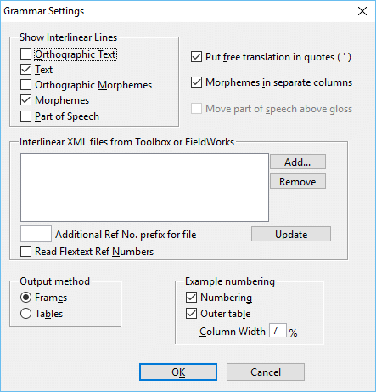
If you uncheck the Morphemes in separate columns, then morphemes will be separated by dashes. You can uncheck Text or Morphemes if you do not want that line included.
If you are using Flex and have several texts, you can specify a Ref Number prefix for each file. For example, the prefix for the first file could be "S1-" (short for "story 1"). Then you can refer to the first example (number 1.1) by typing "#S1-1.1". If you are using Toolbox or you have only one FieldWorks text, then there is no need to set a prefix.
By default OOLT will automatically number examples from Flextext files as [paragraph number].[phrase number], as Flex typically does. However if your Flextext files have different ref numbers and you want to use those numbers instead, you can check “Read Flextext Ref Numbers” for each file. For example ParaTExt may use verse numbers as the Ref Number.
There are two methods for output: frames and tables. Frames are more flexible for changing font size or removing words. However some people prefer tables in order to select rows and columns more easily. If you want to save a copy of the document in .doc format, you may find that it is necessary to use tables.
By default example numbers are inserted in a separate column. This makes it line up nicely. If you need to use high example numbers (over 1000 for example), you may need to increase the column width. When you change the column width, Linguistic Tools will attempt to resize all examples already in the document.
In order for examples to be in a separate column, an outer table is created. This is normally recommended. However if you need to put several examples inside of another table, this may not be what you want. To avoid this, uncheck Outer table. Example numbers will still be added, but they will not be lined up as well. A drawback of unchecking Outer table is that it will not be possible to update these examples automatically. More information on updating examples is given below.
If you do not want example numbers at all, then uncheck Numbering.
People who are competent with computers may want to add orthographic data to their write-ups. In OOLT, there are two basic kinds: Word (Text) and Morpheme data. In FieldWorks, these lines are just an additional writing system, and it doesn't matter which one is which, because OOLT simply keeps them in the same order. In Toolbox, use \tor and \mor, and make sure they are at the correct position in the hierarchy.
Often in Flex and Toolbox, orthographic lines are generated by lookup or conversion processes. It is beyond the scope of this document to give instructions for these processes.
To insert examples, go to Linguistics → Get Grammar Examples. This is similar to the method of getting phonology examples described above.
To change font size or color, go to the Styles and Formatting pane and select Custom Styles in the box at the bottom. Select the Paragraph Styles icon at the top. Right-click on the style, for example Interlin Base, and select Modify. If you are using frames, then the frames will automatically adjust as you change the font sizes.
If you are using tables, it is okay to make the font smaller, but making the font bigger will often cause the morphemes and words to be too big to fit, and then it will not look good. In this case it is probably necessary to update all of the examples after making the font size bigger.
If the spacing of the table does not look right, please check the "Table Contents" paragraph style. Right click on the style and select Modify. In the Indents & Spacing tab, everything should be set to 0.00, and line spacing should be Single. Often documents from MS Word have this style set incorrectly.

Updating Grammar Examples
If Outer table is checked in Grammar Settings, then it should be possible to update examples using the Linguistics menu. Before updating examples it is recommended to save the document. Then go to Linguistics → Get Grammar Examples, and specify to Update existing examples. Press Find Next, which will find the reference number of an example that you have put into your document earlier. When a reference number is found, press Update Example to get the new data. This will do three things:
- Insert an updated example.
- Delete the old example (but it will keep the example number field, so cross references should not be affected).
- Put a copy of the old and new examples in a comparison document for checking.
After updating a number of examples, you should go to the comparison document that gets created automatically. In this document you can review the changes, and if something is not right, click the button to go back to the main document and fix the problem. For example, if you notice that one of the words should be formatted in Bold in the updated example, then make it Bold in the main document. The button should move the cursor to the example, but it may be necessary to press an arrow key to scroll to the cursor. When finished checking, close the comparison document without saving.
It is recommended to use a comparison document for checking. However if you don't want it to be created, set LTg_ComparisonDoc to 0 according to instructions in Advanced settings.
If you are confident that updating examples is working, then you can try using the Update All button. However there may be problems. So before updating all grammar examples, make sure to save a backup copy of your document. Then click Update All. You may be able to see when each example is updated, but often OpenOffice will stop responding because it is busy updating all of the examples. When this happens, please wait for about 10 minutes or so to let it finish. If after a long time it is still not responding, there may have been some problem. In that case you may need to force OpenOffice to close.
If the "Update examples" feature does not do what you need, here is a more advanced method:
- Set the Interlin Reference Number style to a font that is different from the rest of the document, for example Tahoma or Arial Black.
- Go to Edit → Find and Replace. Click the button to show More Options. Click on the Format... button. Set the font from step 1 and press OK. Then check Including Styles. (If you do not see the "Including Styles" option, then close the Find dialog, move the cursor outside of any tables, and then try again.)
- Press the Find All button. Now all of the reference numbers should be selected.. Press Close, and Copy the reference numbers (Ctrl + c). Open a new Writer document and then paste them (Ctrl + v).
- Now we need to add # in front of each number. To do this, go to Edit → Find and Replace. Click more options, and click No Format (to clear the search from step 2). Check the Regular Expressions box. In the Search For box, type one space followed by {1,4} (open curly brace + one + comma + four + close curly brace). In the Replace With box, type \n# (forward slash + n + number sign). Press Replace All.
- In the new Writer document, go to Linguistics → Grammar Settings and specify the file and font settings just as in the main document. You may also want to uncheck Numbering, which means you will need to copy and paste the old example numbers. The advantage of this is that any cross-referenced example numbers will be kept.
- Now go to Linguistics → Get Grammar Examples. First press Find Next Reference and then Replace with Example. If it is working correctly, then click Replace All. As with updating all examples, OpenOffice may stop responding for awhile, in which case you probably need to wait until it is finished.
- Now cut and paste the examples into the writeup. You will probably want to check each example one at a time, because there may have been changes.

Grammatical Abbreviations
One of the things required for a grammar writeup is maintaining a list of abbreviations. A list is normally kept either at the beginning or the end of the document that tells what the abbreviations mean. However this list is difficult to maintain, and it is easy to be inconsistent with labels. To help with these things, use the Abbreviations tool.
When you first go to Linguistics → List of Abbreviations, it will begin with a default list taken from the Leipzig Parsing Rules. Please go through this list first and make some corrections. Don't worry, if the abbreviation is not used in your document then it will not show up later. To correct an item in the list, select it, change the abbreviation or full name, and press update. If it is not in the document but you want it to be included in the list anyway, check Output even if not found and press update.
If the abbreviations are all CAPS and this is not what you want, there is a button to change the list to either lowercase or just the first letter capitalized. Press the button to change the list from CAPS to lowercase, and press it again to change from lowercase to first letter capitalized.
To add new abbreviations, type in the information and press the Add New button. You can also use the Delete button to remove abbreviations, but there is no need to delete all of the unused abbreviations because they will not show up.
Now click "Scan for occurrences." This will search through the document and count how many times each abbreviation is used. If the abbreviation is not found, then it will not be included when the list is inserted.
There are probably more abbreviations in your document that you haven't found yet. That is what the upper right-hand section of this window is for. Select a paragraph style to search in, probably either Interlin Gloss or Interlin POS. If your language is head final (typical in South Asia), then leave suffixes selected. Or you can specify Any which will give more results. You can reduce the maximum length to 4 or 3 to look for short abbreviations. Also if the abbreviations are all upper case (for example GEN for genitive), then check upper case.
Now click Search. If an abbreviation is found that needs to be added to the list, click Yes, otherwise click No. Keep doing this until all of the abbreviations are found that you need. After this is finished, go through the list and add full names for the abbreviations. Make any other corrections that are needed.
When the list is finished, click "Insert List" to insert the list into the document at the present location. The list uses a paragraph style that you can use to format it.
If you press "Close" then any changes to the list of abbreviations will be saved.

Data Conversion
In order to use Data Conversion on Windows, please download and install SIL Converters. On Linux, download and install FieldWorks, which includes the SIL Converters core libraries.
After SIL Converters is installed, go to Linguistics → Data Conversion.
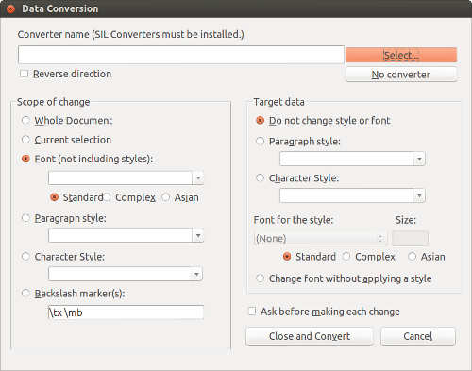
Clicking Select should bring up the SIL Converters window, where you can add new converters or make changes. If you want to convert from the right encoding to the left one, then check Reverse direction. After selecting the converter you want to use, press OK to close the SIL Converters window.
If you want to use the Data Conversion tool to set a new paragraph style but you don't want to do conversion, then click the No Converter button. Keep in mind that OpenOffice's Find and Replace menu has a number of features to make powerful changes to styles and formatting, so that may be a better approach than using the No Converter button.
Specify the scope of change that you want to do the conversion on, either the whole document or a selected part of it, or a font or style. To change complex fonts (such as Tamil script using Latha unicode font), choose complex instead of standard. If a particular font is not shown in the list, just type it in the box. The list does not necessarily show all fonts used in the document.
Currently, specifying the whole document will not look in frames or headers. However, specifying a paragraph style (for example the Default style) or standard font will look in frames and headers.
It is also possible to open an SFM file and convert by backslash markers. However for large files it may be better to use the SIL Converters Bulk SFM Converter.
To convert to a new style, first create the style in the Styles and Formatting pane. Then go to Linguistics → Data Conversion, click the appropriate style radio button for the target, and select the style you created. Alternatively in the Data Conversion window, you can type in the name of a new style and select its font, and OOLT will create the style.
It is usually better to convert to a style in case changes need to be made to the font or size later. However if you don't want this, select "Change font without applying a style." Then the font will be changed but no style will be created.
One useful approach with the Data Conversion tool is to first use OpenOffice's Find & Replace menu to set a style. You can search by text, color, size, or many other things. To do this, go to Edit → Find & Replace. Click More Options, and click the Format button. Specify the color, size, or font that you want, then press OK. Now press the Find All button, then press close. The results should still be highlighted. You can set the highlighted results to a particular style. Now use the Data Conversion tool to make changes to that style.
After making changes to the settings, click Close and Convert.
For large documents with many changes, it may run out of memory if the scope is a font, style or backslash marker. If this happens, you can try setting LTc_MatchLimit to a number such as 100 using the instructions in Advanced settings. Then run the conversion multiple times until the entire document is finished.

Word List
A word list can be useful by itself, or it may be used for spell checking. Go to Linguistics → Word List and Spelling to bring up the following dialog:
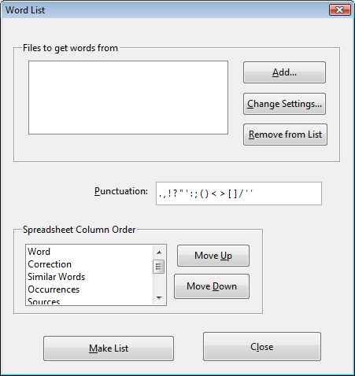
Click Add to bring up the File Settings dialog. Click Browse to find a file to grab words from. This can be any type of file shown in the Type of File list, which includes documents and different kinds of data files. Instead of browse, clicking Current Document will use whatever is currently open. For the type, selecting Document will use Writer, which can open various types of files including plain text files. If Writer does not open the file correctly, try opening the file manually by going to File → Open.
Depending on the type of file, there are different fields that can be searched. For example, it is possible to search documents for a paragraph style. To do this, select or enter the paragraph style, then press Add item. Searching documents is similar to Data Conversion, so the information in that section regarding scope of change applies here. To read data from an SFM file such as an AdaptIt Knowledge Base, enter an SFM marker such as \lx and then press Add item. For XML data files such as Paratext, choose a field to grab words from.
When finished, press OK. If necessary, it is possible to change the punctuation that the tool looks for in order to determine what counts as a word. Numerical digits are ignored by default.
Depending on what you plan to do with the word list, it may be helpful to rearrange the columns of the spreadsheet that will be created. For example, you may want to have a column next to the word that shows its romanized form, in case the script is non-Roman. If so, move the Converted 1 column up to just after the Word column, by selecting it and clicking Move Up.
When ready, press Make List. For large word processing documents, this can take some time, but for files such as XML data it should be pretty fast. If all goes well, a spreadsheet will be created with the words found under the Word column, and the files it was found in shown under the Sources column.
Notice the Linguistics menu is different in Calc:
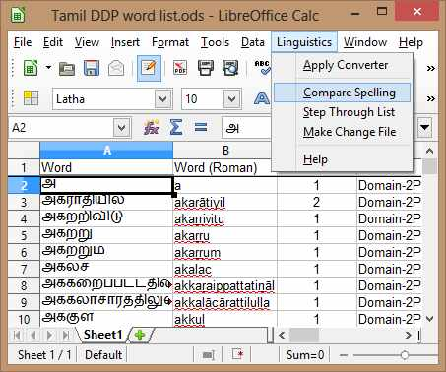
If the words show up as boxes, you may need to change the font in order to see them properly. To do this, select a column by clicking on column A, but deselect the "Word" heading by holding down control and clicking on "Word". Then change the font and size as needed.
The data starts out sorted by the words. To sort by something else, for example number of occurrences, click one of the cells in the first row, then go to Data → Sort. Change Sort key 1 to Occurrences and press OK. Sorting by Occurrences can be a good way to find typing errors.
It may be helpful to run a converter on the list, for example to romanize it. To do this, go to Linguistics → Apply Converter. By default, the converted values will go in the Converted 1 column. To put the new values in a different column, change the letter.
More complex sorting is also possible. To sort by word endings for analyzing suffixes, enter a heading called "Reversed Word" in another column such as column I (capital Eye, not Ell or One). In the next row, enter the formula =REVERSE(A2). Then fill this down column I far enough for the whole list. Now click in the first row, go to Data → Sort and sort by Reversed Word. In the same way, it is possible to sort by word length using the formula =LEN(A2).
Formulas can be used to make changes as well. One formula could add \lx in front of the words, to save the word list as SFM format. The formula would be ="\lx " & A2. Then copy and paste the result column into Notepad or another text editor.
To save a word list, just save the spreadsheet. However this will not save word list or spelling settings. To save settings, you also need to save the Writer document. To use the settings again later, open both the Calc spreadsheet containing the word list and the Writer document containing the settings. The settings can be viewed or changed in the Writer document as described in Advanced settings.

Spelling Tools

Compare Spelling
When the word list is ready, you can use Compare Spelling to help find mistakes. This is particularly useful for languages where words may be spelled in more than one way, such as Indic languages. (For languages where spelling is more rigid, such as European type languages, see List of Good Spellings). In the dialog, choose the script, for example Tamil. For roman-based scripts, choose Latin. To check for inconsistencies in long and short vowels, check the Vowel Length box, which will add vowels of different lengths to the Characters to Compare box. Check all of the boxes you want to compare. Then add, remove or make changes to the Characters to Compare list based on your language. Characters on a line will be compared with each other.
When finished, press Check Word List. For a large word list, it can take some time to compare all of the words. If inconsistencies are found, they will be added to the Similar Words column. It may be helpful to sort by Similar Words in order to see all of them easily. Then if there are any words that need to be corrected, copy and paste or enter the word in the Correction column.
An easier way to fill the Correction column is to use the Step Through List menu item. This brings up a dialog that goes through each row one at a time. To make this process easier, be sure to sort the data first, because it will step through each row in order. To go to a row, slide or click the scrollbar or enter a new row number. At each row, it gives options for changing the Correction column. If you have run Compare Spelling first, then it will give the choices in the Similar Words column for that word. By default the dialog will also give suggestions by comparing the word with other words in the list. If going through rows is slow and you don't need this, then uncheck "Give other suggestions" to make it faster. To select one of the changes, click on the change or make manual changes and then press the Set Correction button. This will also change the Correct status to "X", meaning incorrect. Clicking again on the check box will change the status to "YES" (correct) or just empty.
After corrections are ready, there are two ways to use the corrections to make changes. For word processing documents, first save the Calc spreadsheet and then open the document you want to change in Writer. Then go to Linguistics → Make Spelling Changes and click "Current Spreadsheet" to use the list of corrections. Leave "Apply List of Corrections" selected, and choose whether to make changes to the whole document or just words in a particular language or style. When finished, press "Search" to start. It will ask before making each change.

Change Files
To apply the corrections to other types of data, go to Make Change File. Leave "Simple Replacement CC Table selected to make changes in another application such as FieldWorks. Click Browse to save the CCT file somewhere you can remember, and press OK. Then open FieldWorks, open the converter selection box, and add a new Consistent Change Table converter. Browse to the file you saved. When finished creating and selecting the converter, run it on your data.
To create a change file to run directly against a file containing SF markers, use the second option, Full CC Table. This type of file can be run from within Toolbox, or it can be run on an SF file using an application such as CCWin.
Most modern applications use either a database or XML data files. It is possible to make changes directly to XML files, but it is more difficult than changing a file containing SF markers. If you want to do this, start by opening up the XML file in a browser such as Firefox or Internet Explorer. It is possible to open the file in a text editor such as Notepad as well, but this will make it more difficult to see the tree structure of the data, and it will be very difficult if the data is not pretty printed. When the file is open, find a tag that you want to change. Then you will need to write an Xpath expression to tell where the tag is in the tree. Documentation for Xpath expressions can be found on the internet. Starting with "//" means that the expression doesn't have to start at the root of the document. Then put each of the node names in between slashes. It is also possible to specify attribute names or their values.
After entering an Xpath expression, press Add. To change other tags, add another expression. By default the changes will match the whole text node. Checking the box to match part of the text will be necessary if the node contains a whole phrase instead of just single words. However this will make it also match parts of words. For example correcting "saend" to "sand" will also change "saendwich" to "sandwich," which may or may not be what you want.
When finished, press OK to create the XSLT file. Then open it in a text editor to check it and make further changes as needed. To use the file to change XML data, run a utility such as Saxon, which is a free download. Ubuntu includes the built-in xsltproc command line tool (for basic instructions enter “man xsltproc”).
This process of spell checking (building a word list and using spelling comparison) may be too complicated and slow. For just a few quick changes, there is a simple way. From a Writer document, go to Linguistics → Word List and Spelling, but don't add any files. Just click Make List to create an empty word list. Now under the Word column, type or copy and paste a misspelled word, and under Correction, type or copy and paste the correction. When finished, use either Make Spelling Changes or Make Change File to make changes.

List of Good Spellings
A more traditional method of spell checking is to check by a list of good spellings, that is, words that are known to be correct. This is a good approach if spelling in your language is fairly strict. One way to do this is to use the built-in OpenOffice spell checker called hunspell. For English or another language that already has a hunspell dictionary, this is probably the easiest approach. Unfortunately building a hunspell dictionary for lesser-known languages requires several complex steps, and is best done using Linux tools. For an easier alternative, use Spell Check by Good List.
To do this, if you already have a list of known good words, start by creating an empty word list. Go to Linguistics → Word List and Spelling in Writer, and with no files in the list, click Make Empty List. Then, copy and paste the list into the "Word" column. This can be done in several ways. For example, open your list of good words in a text editor such as Notepad and then copy and paste. Or import the text file from Calc by going to File → Open, or drag the file into Calc.
If you do not already have a list of known good words, it may be helpful to make a word list from several other files that have mostly correctly spelled words. Then make any corrections needed. Another option is to just start with a blank list and build up the words as you go by pressing Add for correctly spelled words, as described below.
When your list of good words is ready, in Writer go to Linguistics → Make Spelling Changes and choose Spell Check by Good List. This will check spelling in the current Writer document.
If you have the Language setting set on the words to check, then specify a language to check spelling on. This should be fairly straightforward if your document uses only standard (western) type scripts.
For complex or Asian scripts, using the Language setting is a little tricky, because OpenOffice does not have a setting that tells which text is standard and which is complex. To do this, as an example, let's consider a document that contains Hindi and English. First be sure to enable complex (CTL) fonts in options if you haven't yet. Then set the parts of the document which use Hindi script to the Hindi complex language, and an arbitrary western language name, for example French. This can be done quickly by modifying each style you are using. Finally, for parts that are in English, set the western language name as English and set an arbitrary complex language name such as Tamil. Now when spell checking, you will be able to specify either Hindi language or English language to check.
If you do not want to spell check by language, then select the whole document or a particular style or font to check. Finally, check the Match Case check box to differentiate between upper and lower case letters at the beginning of a word.
When finished, press Search. For each word found that is not in the list, the dialog will give a list of suggestions, as well as a text field where you can make any manual changes to the word. Pressing "Add" will add the word to the good list without changing. Pressing "Change" will make the change without adding. Changed words that are not yet in the good list can be added later when running the check a second time.

Script Practice
Go to Linguistics → Script Practice to bring up settings. Let's use the option "Generate Random Words." Choose a script to practice, for example Latin. Based on the script, a font will be selected automatically. You can press "Next" to choose a different font if more than one known font is available for the script. Or you can select any font from the drop-down list.
In the "Characters to use" box, it will list a set of characters for the script. To only practice a few characters, delete the ones you don't want. To practice additional characters that are not listed, enter each character separated by one or more spaces. The add-on will try to guess what type of characters they are, for example word initial letter or dependent sign.
Also you can specify what size words to generate. A maximum syllable size of 3 will try to give a typical CVC word pattern, size 2 will normally be CV, and size 1 will probably just give single consonants. You can also specify more than one syllable per word, and more than one word at a time. For Latin, let's specify syllable size 3 and 2 syllables per word.
When finished, press "Go to Practice." The word or phrase will appear in the yellow box, and you need to type it in the white box below. After you type it, hopefully it will turn green because it's correct. If so, you can press space or enter to go to the next word. If it's wrong however, it will turn red when it is long enough to check. In this case press space or enter to retry.
If you are finding that the answer turns red before you are ready, you can select "Press Space or Enter afterwards." This means that it won't check the answer until after you press space or enter. This may be helpful when entering longer phrases. Also some keyboard layouts require more than one keystroke to change the last letter, and in that case you may want to use this option.
To type in non-roman scripts, if you have not yet done so, you need to install and configure keyboard layout software. After it is set up, when the Script Practice dialog window is open, you will need to manually activate the keyboard layout software. Normally this can be done from a small menu in a panel on the desktop. The Script Practice module does not provide an automatic way to activate the layout.
If the question gets too big for the question box, go back to the settings (click the button "Back to Settings") and change to a smaller font size.
Instead of practicing randomly generated words, it is possible to load a word list. It may be helpful to first create a word list in a spreadsheet, and then use this spreadsheet for script practice. To practice with phrases instead of single words, in the File Settings dialog, uncheck "Split phrases into words by space." Also check "Skip first row when reading spreadsheet" so that it ignores the "Word" heading. For more details about word lists, see Word List and Spelling.
To save settings for Script Practice, you may want to save the Writer document. You can save it even if it is empty, and it will keep the settings.

Advanced settings
If you are careful, you can make changes directly in the settings of the Linguistic Tools add-on. These settings are stored in the Writer document. Note that the settings cannot be stored in Calc spreadsheets such as word lists, nor in Microsoft formats such as .doc or .docx. First, set basic settings if you have not yet done so, for example Linguistics → Grammar Settings. Next, go to Insert → Fields → Other, or press Ctrl + F2. Go to the Variables tab and select User Field. All of the variables beginning with "LT" are for the Linguistic Tools add-on.
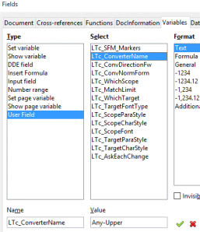
One example is that you could change which style is used for interlinear glosses. Select the LTg_GlossStyle variable. The normal value is Interlin Freeform Gloss. However you could use a different style instead, for example Gloss1. Change the value to Gloss1 and press the green check mark to apply. Now the style Gloss1 will be used instead.

Formatting write-ups
Here are some suggestions for using OpenOffice to format linguistic write-ups.

Navigator
Many people want to easily see the headings in their document. To do this, go to View → Navigator. It is best to "dock" the Navigator window so that it is attached to the main window. This can be done with the mouse, although in many versions of OpenOffice it is tricky. In Windows, click in the title bar of the Navigator window, and drag it around the left edge of the main window. When you see an outline appear, then it will dock when you release the mouse button. It is even trickier in Linux: Hold down Ctrl+Shift and double-click in the ICON AREA of the Navigator window (not the title bar).

Cover page
It is probably best to use the Styles and Formatting pane also. To do this, go to Format → Styles and Formatting. This will show a window pane on the right side where you can view all of the styles.
In the Styles and Formatting pane, click on the Page Styles icon at the top. Now right-click on the white area in the pane, and select "New..." This will bring up the Page Style dialog window. Change the name to "My Cover Page." Click OK to create the new style.
Also create two other page styles called My Table of Contents and My Document Body. Then modify the My Cover Page style so that My Table of Contents is the Next Style, and modify the My Table of Contents style so that My Document Body is the next style.
Go to the first page and double-click "My Cover Page" to apply the style.
To center the title on the cover page, go to Insert → Frame. Set Anchor to Page, and choose Center for both Horizontal and Vertical position. Then press OK. Now you can type the title in this frame.
Then insert a page break (Insert → Manual Break), selecting the style as My Table of Contents.

Page numbering
Go to Format → Paragraph and click on the Text Flow tab. Under the Breaks section, check Insert and With Page Style, and set Page number to 1, and Style to My Document Body. Then click OK.
Now go to Insert → Footer → All. Click to move the cursor in the footer. Then go to Insert → Fields → Page Number. If you set up the page style correctly, this should show the page number as 1.
To show the total number of pages (for example "Page 1 of 17"), click in the footer and press F2 to bring up the formula bar. Enter the formula =page – 3. You will need to change this number 3 to the number of pages contained in your document before the body begins.
To see the new page numbers, go to Tools → Update → Fields (or press F9). Or, to get page numbers to update, File → Page Preview.
You may also want to add page numbers that look like "iii" to the table of contents pages. To do this, insert a footer and page number field. Then double-click just before the page number field. This brings up the Edit Fields dialog. Select the Roman (i ii iii) format and click ok.

Warning: The offset field in the Edit Fields dialog provides a quick way to change the page numbers to start at 1. However, do not use this feature. It is better to use page styles.
You may notice that inserting a page break that creates two odd numbered pages in a row, for example iii followed by 1, causes an extra blank page to be printed. If you have this problem, go to Tools → Options, and under OpenOffice.org Writer, select Print. Uncheck "Print automatically inserted blank pages." Later, if you want to Export as PDF, you will want to uncheck "Print extra blank pages" in the PDF options.

Table of contents
On the table of contents page, go to Insert → Indexes and Tables → Indexes and Tables. To change how the Table of Contents looks, go to the Entries tab. Here are some suggestions:
- Click in white space before E, press Hyperlink button.
- Click in white space after E, press Hyperlink button.
- Click in white space after E#, use space bar to make one or two spaces.
- Click on LE
- Select a style of just Arial, no underline. (I made my own style for this purpose).
- Click All button
- If you need to delete a button, you can click on it and then press the Del key.
Also in the Styles tab, you may want to make some changes:
- 1.5 line spacing for Headings 1 and 2
- Add spacing before Heading 1

Outline numbering
For linguistic write-ups, many people use outline numbering for section headings, for example section 2.1. A good way to do this is to go to Tools → Outline Numbering.
In the Outline Numbering dialog box, first select level "1-10." This modifies all levels. Select "1,2,3" for the number format. Change Show sublevels to 10. In the Separator, After field, type a period (.) followed by a space ( ).
Next, select level 5. Set number to None, and show sublevels to 1. Leave the Separator, After field blank. Click Ok to make changes.
I found it helpful to use heading 5 for acknowledgments and bibliography. In this case, you may want to edit the heading 5 style. In the Styles and Formatting pane, click the Paragraph Styles icon at the top. Right-click on Heading 5 and choose Modify. In the Indents and Spacing tab, set Before text to 0. In the Font tab, set size to 14 (or whatever you choose).

LSA bibliographies
If you have Firefox, then I recommend using a plug-in called Zotero for citations and bibliographies. It has the LSA stylesheet built in. Go to the web site http://www.zotero.org/ and download the latest stable version, and install it as a plug-in in Firefox.
Then go to Cite from within Word and OpenOffice and scroll down on that page and click on Installation. Download and install the OpenOffice extension.
If you want to use LSA format, you can download a stylesheet. Click on the link from the Zotero home page to use thousands of bibliographic styles. Shorten the list by clicking on the linguistics field. Install the Unified style sheet for linguistics journals.
To use Zotero, first add bibliography entries in Firefox. Then in OpenOffice, go to View → Toolbars, and show the Zotero toolbar. You can use the toolbar buttons to configure Zotero and insert citations and a bibliography.
If there is an error connecting to Firefox, then make sure Firefox is open. If the computer is not connected to the internet, then in the File menu of Firefox, uncheck Work Offline.

Other tips
To create a new style, first select some text and format it the way you want it, for example Bold size 14. Then in the Styles pane, click the "New Style from Selection" button.
To set some text to a different style, select the text, then double-click on the style. If you are mostly working with custom styles, then you may want to select "Custom Styles" in the box at the bottom of the Styles and Formatting pane.
To insert a cross reference to a heading, go to Insert → Cross Reference. Select type as Headings. Then select the heading that you want to reference to. Set "Insert reference to" as "Number."
To delete a page break, it may not be enough to press Backspace. If Backspace does not work, go to Format → Paragraph, and under the Text Flow tab uncheck the Insert box. Paragraphs, tables and other objects can force a paragraph break in this way.
To change page settings such as landscape, go to Format → Page (not in the File menu like some other applications).

Technical notes
If you are interested in seeing how the add-on is made and perhaps making changes, then simply unzip the .oxt file. Most of the code is in Python, under the pythonpath directory. You can make changes, zip it back up, and then reinstall it.

Contact
For questions or feedback, please contact <jim_kornelsen@sil.org>.

Thanks to David Rowe and Phil Leckrone for the translations.
If you want to install it in both LibreOffice and Apache OpenOffice, only one of them will open by default. To install it in the other one, go to Tools → Extension Manager, press Add, and browse to LinguisticTools.oxt.
In OpenOffice.org 3.0 for example, the new dialogs will not load without restarting OpenOffice. This will result in the message “Error: Could not show dialog."
Ubuntu uses the system-wide python by default, so no additional packages should be necessary.
If the Source note is empty, then OOLT will look for an Example Reference note or a custom Reference field. To force OOLT to always look in a particular place, set variable LTp_RefNumIn to either SourceNote, ExampleRefNote or CustomRefField respectively. See Advanced Settings for how to set variables.
It is possible to use different field markers by specifying them in Advanced Settings. See also the instructions in the Grammar section for using different tags.
To use it as the phonemic field instead, set variable LTp_ExperTrans_Phonemic to 1.
As of this writing (November 2015), the latest versions of Phonology Assistant no longer have an option to export as XML. According to the developer, Phonology Assistant may export LIFT format in the future.
This reads the segnum field, which is not used by older versions of Flex.
If the main document hasn't been saved, then buttons will not be created in the comparison document. Also multiple comparison documents may be opened.
If there are no buttons in the comparison document, see footnote 10.
Searching for complex fonts and character styles is not a built-in part of OpenOffice, and this has some limitations as well. For example it will not look in frames.
As time goes on, the types will probably change and expand in an attempt to keep up with changes in language software such as Paratext, Toolbox, FieldWorks, Phonology Assistant, and AdaptIt. If you find a new format that is not in the list or is not handled correctly, let me know and I may be able to make it work in a new version.
This setting can even read marked up data files such as XML and SFM, but the data is likely to get mixed up that way. If possible use one of the other options for such files.
Like Data Conversion, this requires SIL Converters to be installed.
The REVERSE() function is an add-in, part of the Linguistic Tools extension.
Why is it considered incorrect when we just corrected it? Well, it means that the word in the "Word" column is incorrectly spelled. The word in the "Correction" column is correct.
The fonts are mostly based on the list at http://www.apaddedcell.com/web-fonts. Specific fonts such as Mangal (for Devanagari) are selected first, and general fonts follow, such as Arial Unicode MS.
More accurately (C)VC, so it will often generate word-inital vowels.
For example some Tamil keyboard layouts include final virama by default, which may need to be deleted before the answer is correct.
It seems to be easier with recent versions of LibreOffice on Windows.
There is also a Language (LSA) stylesheet available on this site, although it no longer seems to be linked.

